[Title Here, up to 12 Words, on One to Two Lines]

# Intro

Although present in day-to-day life, boring activities drive people away from lucrative activities buying video games and movies. Marketing has long discovered that big lengths in commercials have detrimental effect in engagement. Would a similar effect exist with movies?

People often say they do not enjoy lengthy movies. Movies vary in length for a plethora of reasons. Be budget, artistic decisions, direction style, studio decisions. However, would be the length of a movie related to its revenue?

Here we explore quantitative data to find if there is any correlation between movie lengths and their scores as reported in the IMDB website. My theoretical hypothesis is that there is a significant correlation between movie lengths and their scores.

# Methods

According to Cohen (1988) to detect correlations in the order of 0.09 with alpha < 0.05 and power of 0.95 it’s required a total sample size of 1331 movies. These numbers were calculated using GPower.

Pearson product correlation will be used. It will be implemented in the R software. A subset of the IMDB database was downloaded from the website Kaggle.

# Results

From the subset of 1331 movies randomly selected a linear fit was made. It’s shown in Figure 2.

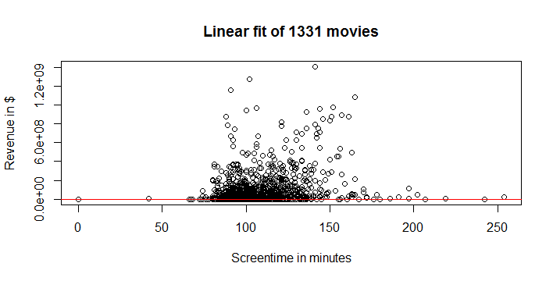

Figure 2: Linear fit of the subset. The fitted line is in red.

R calculated Pearson's product-moment correlation to be 0.2438332 , 95 percent confidence interval of 0.1925862 to 0.2937538 (t = 9.1588, df = 1327, p-value < 2.2e-16)

# Discussion

Statistical analysis performed in a vast subset of movies revealed that there indeed is an small correlation between revenue and screen time. As the association is small it’s uniquely that the next three hour long movie will be a hit, which indeed happens. In our day-to-day life we can’t see this correlation despite data showing it exists. Considering that the subset takes into account movies from a somewhat big release date timespan (as shown in figure 3) we can reasonably conclude that more than one generation tend, although very slightly, to like bigger movies on average.

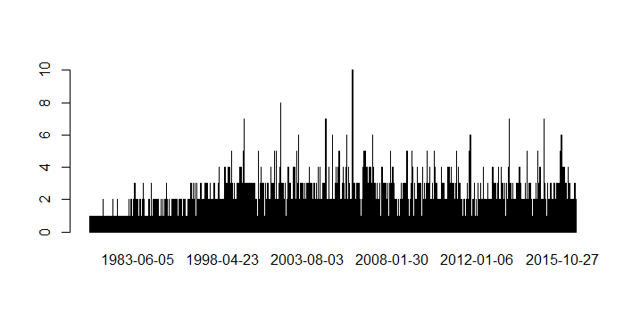

Figure 3: release dates of the movies in the full 5000 movies dataset

# Conclusion

Data from 1331 movies revealed with high significance that there is a weak correlation of the order of rho ~ 0.24 of revenue and length of movies from a dataset considering random movies since the 80s to mid-2010s. Future investigations can further explain this correlation checking for what makes a movie be bigger or effects associated to the length of movies, such as public and availability in theaters.